**[Top 50 Linux Commands You Must Know as a Regular User](https://www.digitalocean.com/community/tutorials/linux-commands" \l "top-50-linux-commands-you-must-know-as-a-regular-user)**

1. [**ls** - The most frequently used command in Linux to list directories](https://www.digitalocean.com/community/tutorials/linux-commands#the-ls-command-in-linux)

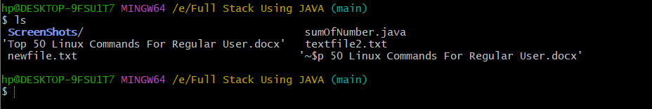

1. [**pwd** - Print working directory command in Linux](https://www.digitalocean.com/community/tutorials/linux-commands#the-pwd-command-in-linux)

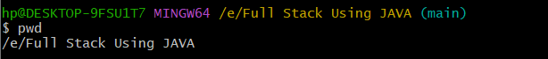

1. [**cd** - Linux command to navigate through directories](https://www.digitalocean.com/community/tutorials/linux-commands#the-cd-command-in-linux)

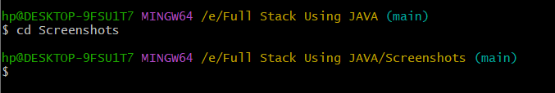

1. [**mkdir** - Command used to create directories in Linux](https://www.digitalocean.com/community/tutorials/linux-commands#the-mkdir-command-in-linux)

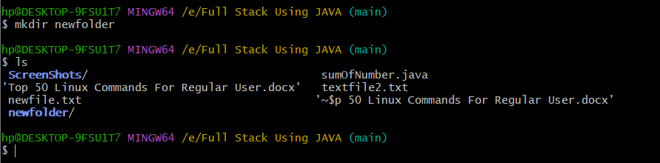

1. [**mv** - Move or rename files in Linux](https://www.digitalocean.com/community/tutorials/linux-commands#the-cp-and-mv-commands)

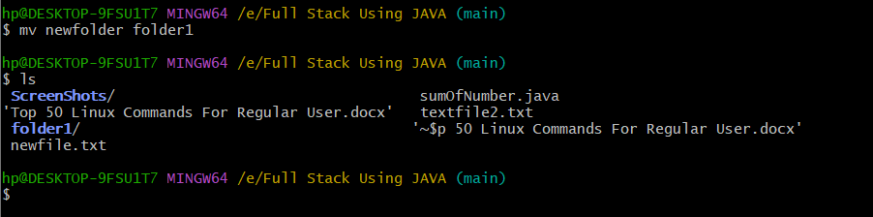

1. [**cp** - Similar usage as mv but for copying files in Linux](https://www.digitalocean.com/community/tutorials/linux-commands#the-cp-and-mv-commands)
2. [**rm** - Delete files or directories](https://www.digitalocean.com/community/tutorials/linux-commands#the-rm-command-in-linux)

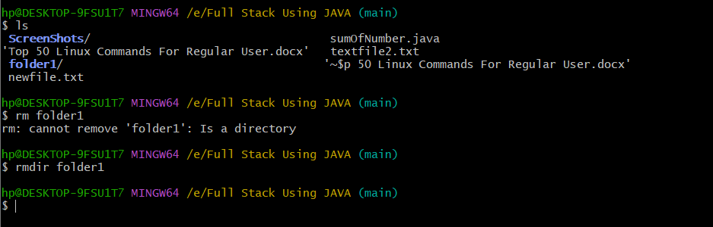

1. [**touch** - Create blank/empty files](https://www.digitalocean.com/community/tutorials/linux-commands#the-touch-command-in-linux)

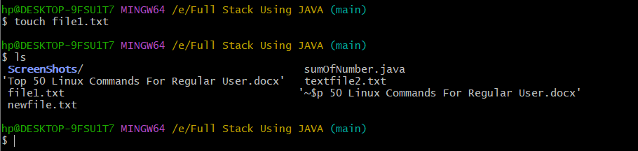

1. [**ln** - Create symbolic links (shortcuts) to other files](https://www.digitalocean.com/community/tutorials/linux-commands#the-ln-command-in-linux)
2. [**clear** - Clear the terminal display](https://www.digitalocean.com/community/tutorials/linux-commands#the-clear-command-in-linux)
3. [**cat** - Display file contents on the terminal](https://www.digitalocean.com/community/tutorials/linux-commands#the-cat-echo-and-less-commands)

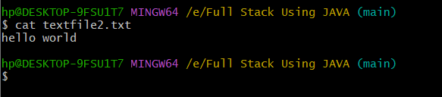

1. [**echo** - Print any text that follows the command](https://www.digitalocean.com/community/tutorials/linux-commands#the-cat-echo-and-less-commands)

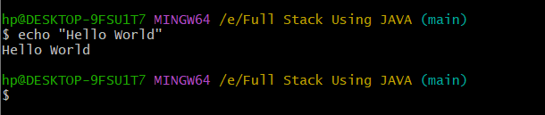

1. [**less** - Linux command to display paged outputs in the terminal](https://www.digitalocean.com/community/tutorials/linux-commands#the-cat-echo-and-less-commands)
2. [**man** - Access manual pages for all Linux commands](https://www.digitalocean.com/community/tutorials/linux-commands#the-man-command-in-linux)
3. [**uname** - Linux command to get basic information about the OS](https://www.digitalocean.com/community/tutorials/linux-commands#the-uname-and-whoami-commands)

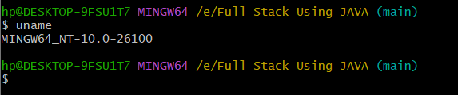

1. [**whoami** - Get the active username](https://www.digitalocean.com/community/tutorials/linux-commands#the-uname-and-whoami-commands)

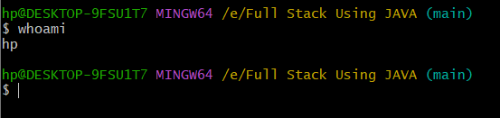

1. [**tar** - Command to extract and compress files in linux](https://www.digitalocean.com/community/tutorials/linux-commands#the-tar-zip-and-unzip-commands)
2. [**grep** - Search for a string within an output](https://www.digitalocean.com/community/tutorials/linux-commands#the-grep-command-in-linux)
3. [**head** - Return the specified number of lines from the top](https://www.digitalocean.com/community/tutorials/linux-commands#the-head-and-tail-commands)

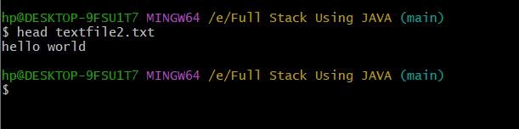

1. [**tail** - Return the specified number of lines from the bottom](https://www.digitalocean.com/community/tutorials/linux-commands#the-head-and-tail-commands)

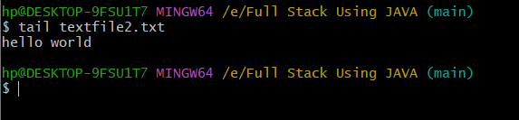

1. [**diff** - Find the difference between two files](https://www.digitalocean.com/community/tutorials/linux-commands#the-diff-comm-and-cmp-commands)

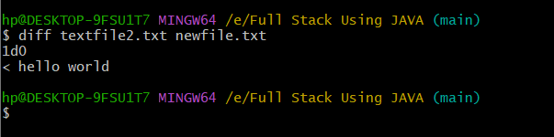

1. [**cmp** - Allows you to check if two files are identical](https://www.digitalocean.com/community/tutorials/linux-commands#the-diff-comm-and-cmp-commands)

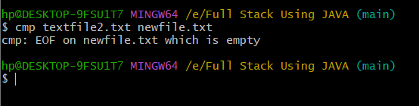

1. [**comm** - Combines the functionality of diff and cmp](https://www.digitalocean.com/community/tutorials/linux-commands#the-diff-comm-and-cmp-commands)

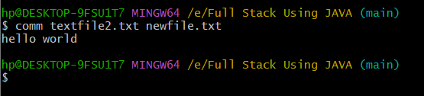

1. [**sort** - Linux command to sort the content of a file while outputting](https://www.digitalocean.com/community/tutorials/linux-commands#the-sort-command-in-linux)
2. [**export** - Export environment variables in Linux](https://www.digitalocean.com/community/tutorials/linux-commands#the-export-command-in-linux)
3. [**zip** - Zip files in Linux](https://www.digitalocean.com/community/tutorials/linux-commands#the-tar-zip-and-unzip-commands)
4. [**unzip** - Unzip files in Linux](https://www.digitalocean.com/community/tutorials/linux-commands#the-tar-zip-and-unzip-commands)
5. [**ssh** - Secure Shell command in Linux](https://www.digitalocean.com/community/tutorials/linux-commands#the-ssh-command-in-linux)
6. [**service** - Linux command to start and stop services](https://www.digitalocean.com/community/tutorials/linux-commands#the-service-command-in-linux)
7. [**ps** - Display active processes](https://www.digitalocean.com/community/tutorials/linux-commands#the-ps-kill-and-killall-commands)

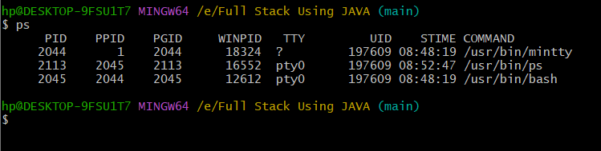

1. [**kill and killall** - Kill active processes by process ID or name](https://www.digitalocean.com/community/tutorials/linux-commands#the-ps-kill-and-killall-commands)
2. [**df** - Display disk filesystem information](https://www.digitalocean.com/community/tutorials/linux-commands#the-df-and-mount-commands)

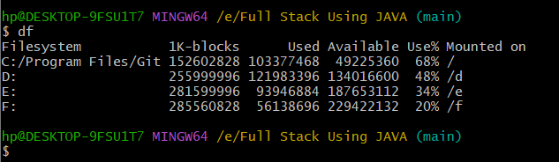

1. [**mount** - Mount file systems in Linux](https://www.digitalocean.com/community/tutorials/linux-commands#the-df-and-mount-commands)

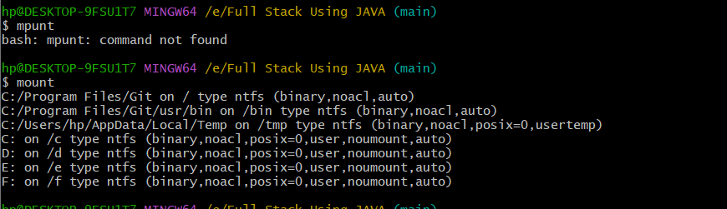

1. [**chmod** - Command to change file permissions](https://www.digitalocean.com/community/tutorials/linux-commands#the-chmod-and-chown-commands)
2. [**chown** - Command for granting ownership of files or folders](https://www.digitalocean.com/community/tutorials/linux-commands#the-chmod-and-chown-commands)
3. [**ifconfig** - Display network interfaces and IP addresses](https://www.digitalocean.com/community/tutorials/linux-commands#the-ifconfig-and-traceroute-commands)
4. [**traceroute** - Trace all the network hops to reach the destination](https://www.digitalocean.com/community/tutorials/linux-commands#the-ifconfig-and-traceroute-commands)
5. [**wget** - Direct download files from the internet](https://www.digitalocean.com/community/tutorials/linux-commands#the-wget-command-in-linux)
6. [**ufw** - Firewall command](https://www.digitalocean.com/community/tutorials/linux-commands#the-ufw-and-iptables-commands)
7. [**iptables** - Base firewall for all other firewall utilities to interface with](https://www.digitalocean.com/community/tutorials/linux-commands#the-ufw-and-iptables-commands)
8. [**apt, pacman, yum, rpm** - Package managers depending on the distribution](https://www.digitalocean.com/community/tutorials/linux-commands#package-managers-in-linux)
9. [**sudo** - Command to escalate privileges in Linux](https://www.digitalocean.com/community/tutorials/linux-commands#the-sudo-command-in-linux)
10. [**cal** - View a command-line calendar](https://www.digitalocean.com/community/tutorials/linux-commands#the-cal-command-in-linux)
11. [**alias -** Create custom shortcuts for your regularly used commands](https://www.digitalocean.com/community/tutorials/linux-commands#the-alias-command)
12. [**dd** - Majorly used for creating bootable USB sticks](https://www.digitalocean.com/community/tutorials/linux-commands#the-dd-command-in-linux)
13. [**whereis** - Locate the binary, source, and manual pages for a command](https://www.digitalocean.com/community/tutorials/linux-commands#the-whereis-and-whatis-commands)
14. [**whatis** - Find what a command is used for](https://www.digitalocean.com/community/tutorials/linux-commands#the-whereis-and-whatis-commands)
15. [**top** - View active processes live with their system usage](https://www.digitalocean.com/community/tutorials/linux-commands#the-top-command-in-linux)
16. [**useradd and usermod** - Add a new user or change existing user data](https://www.digitalocean.com/community/tutorials/linux-commands#the-useradd-and-usermod-commands)
17. [**passwd** - Create or update passwords for existing users](https://www.digitalocean.com/community/tutorials/linux-commands#the-passwd-command-in-linux)